Briefing
Proper planning prevents poor performance. We'll now start retraining your existing learning habits. Identify what makes people plateau and how to avoid them so you can keep your improvements steady.
Overview and recommendations
Key dimensions | Deep processing, self-regulation, self-management, retrieval, mindset
Recommended pace | Most learners see best results with 4 hours of theory across 2 weeks.
Recommended practice | Most learners see best results with 2 weeks of practice while learning theory as recommended above.
Progression tips | If you have adequate competence with the earlier stages, much of this stage is a recap. The focus is bringing multiple techniques together into a cohesive system. We recommend prioritising your time on the "Right vs. wrong way to practise" lesson, which teaches you about Kolb's cycle, one of our pillar techniques. The remainder of the stage can be thought of as a full-system checklist.
How this stage helps you
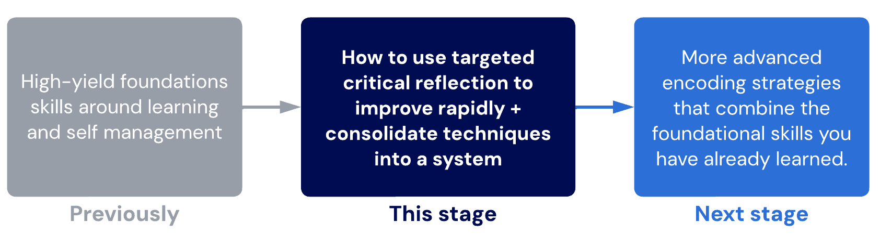

Lessons
- Phase structure
Learn how the Growth Phase is designed to fast-track your development.
- Right vs. wrong way to practice
Practice only makes perfect if you practice the right way. Most people do not. After this lesson, you won't be "most people"!
Sublessons:
- Practice guidelines
- Stages of learning

- Expectations
In this lesson, we outline the expectations you need to have for the Growth phase compared to the rapid pace of the High-Yield phase.
Sublessons:
- Tips and tricks trap
- Common traps
Being an efficient learner is as much about not doing the wrong thing as it is doing the right things. Let's learn what the "wrong" things are.
- Must do's
With the traps out of the way, let's now examine your current system to ensure you're ready for the next steps.
Sublessons:
- Prestudy
- Revision
- Focus
- Techniques in school

- Learning self-diagnosis
The most powerful skill of any learner is to be adaptable. In this lesson, you'll unlock the core skills and perspectives to perform a skills audit.
Sublessons:
- Story of Sam
- Logical alignment
- Confidence
- Gear checklist

- Phase structure
By now, your foundations are strong, and there shouldn’t be any gaping weaknesses with your study methods. Now, let’s elevate them to the next level!
The Growth Phase is broken down into 5 parts.
1. Basic skills and "fitness"
We’ll start off by addressing some essential foundational techniques to refine your system. We’ll also ensure you have the cognitive fitness to ascend smoothly in the later stages.
2. First climb
Using your new skills may seem daunting and difficult at first, and it may seem like you are not progressing. We'll give you tasks and tools that help you to self-diagnose and adapt your learning effectively (even without us)!
3. Base camp
We’ll start adding higher-level skills and mindsets that build on everything you've mastered so far. Most people choose to spend months at Base camp to let themselves acclimatise to their new systems.
4. Push to summit
If the first 3 stages are done correctly, this is the easiest part of the program! On the other hand, people who rush through will find these techniques either impossibly difficult or completely useless (as they don't even realise they are doing it incorrectly)!
5. Summit
Reach whatever learning goal you want. By this point, you've been equipped with the tools and trained your brain to think, learn and adapt to any learning challenge. Summit is the level of true confidence based on a track record of consistent results and refined processes.
A special exam is unlocked upon completing Summit. This exam must be passed to apply for the iCanStudy coach training program (for those interested in pursuing a career in learning coaching)

Recommended tasks
Add tasks to your focus list so you can practice the skills.
Dimensions
Briefing
Schedule your growth plan
As you did before in the High-Yield phase, schedule your theory and practice time using the time management principles we've already taught you.
During the Growth phase, we recommend the following:
  - Add a 30-minute block for critical reflection and planning at least twice per week (preferably daily if possible). We will upgrade your critical reflection technique shortly.
  - No more than 3 hours of theory per week. The amount of practice vs. theory in the Growth phase is generally higher than during the High-Yield phase. More than 3 hours of theory per week is likely to cause overload.
  - Continued spaced interleaved retrieval. During the Growth phase, you must continue to refine your mastery over SIR. As this can take a while, we will not be teaching you any more retrieval techniques for the next few stages. Don't forget to keep up with SIR, even if every lesson doesn't remind you!
Once you have created an appropriate schedule for at least the next 2 weeks, mark this task as complete. Repeat your scheduling and planning every fortnight.

2.Right vs wrong way to practice
Practice does not always make perfect.
In fact, practice can even be harmful! Practice only makes perfect if you are practising correctly.
Many people practise the wrong way. This causes slower rates of skill development and improvement, wasted time and effort, and unnecessary mistakes. While mistakes are crucial for learning, we must have the skills to learn from them. Learning from mistakes is a success. Those who struggle to learn from mistakes also struggle to prevent the same mistakes from occurring repeatedly.
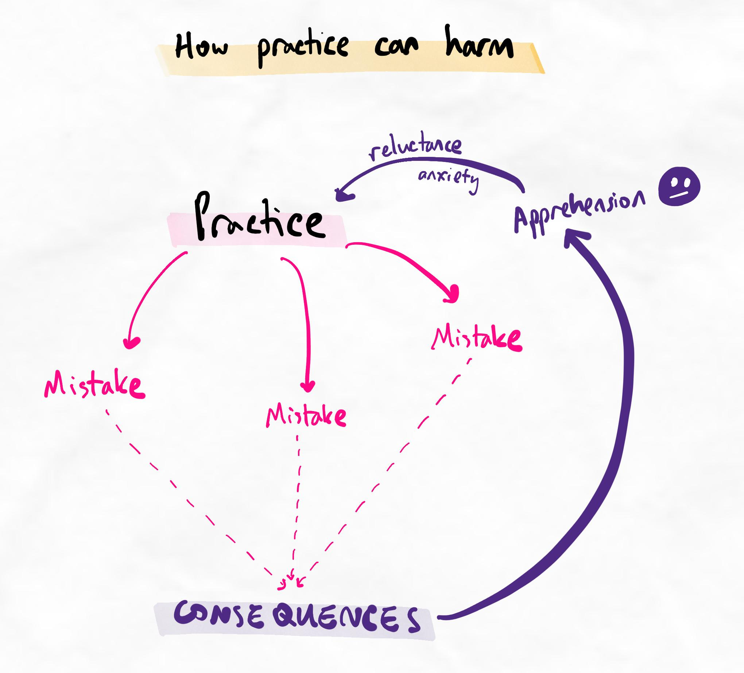If we don't learn from our mistakes, practice is meaningless.
So, how do we practise the right way?
Kolb’s Experiential Learning Cycle is a useful tool for making practice more productive. The stages are as follows:
- Experience
- Reflection
- Abstraction
- Experimentation
Important note
What we teach is a modification of Kolb's experiential learning cycle. Please avoid learning this technique from other sources, as the way we teach Kolb’s is different to how it is typically presented. Our modifications arise from years of experience teaching this framework and observing the subtle practical limitations of the original cycle.
When we learn how to reflect efficiently, we create a safety net for our mistakes. Instead of leading to undesirable consequences, they are transformed into valuable and exciting learning opportunities!
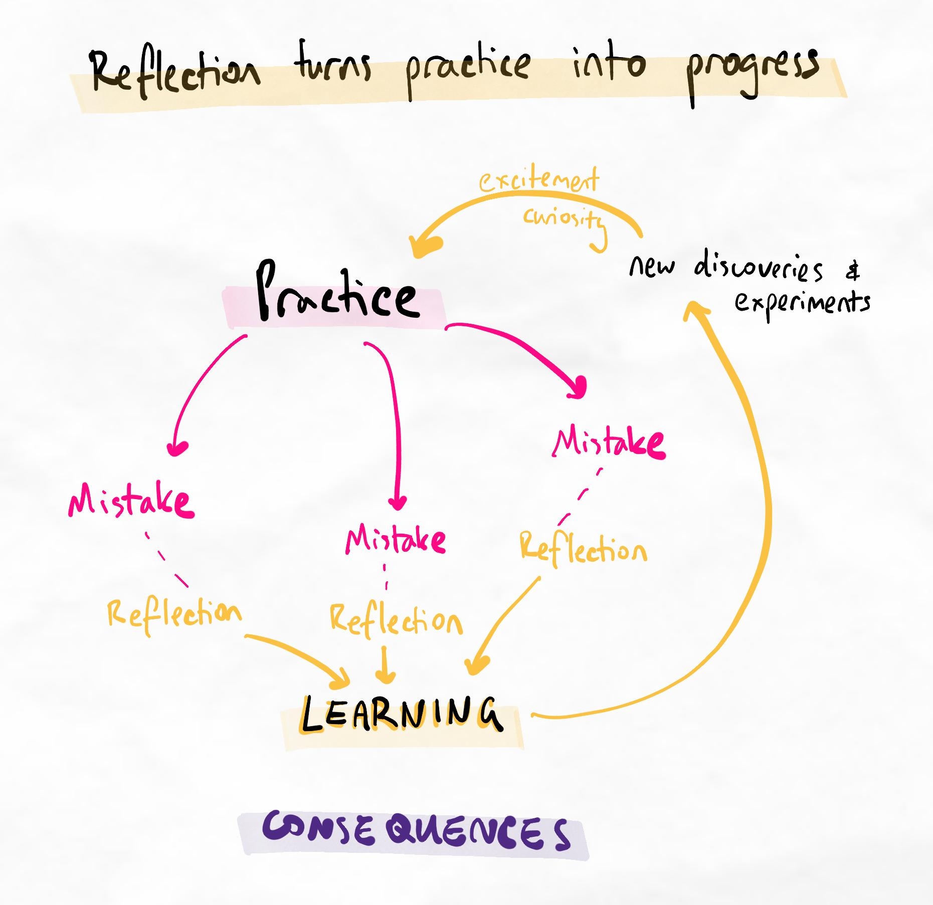Kolb's allows mistakes to lead to learning instead of undesirable consequences.
References
Learning and adapting from mistakes is about knowing what you are doing (monitoring) and changing your methods. The following research shows that people are generally very bad at making meaningful adjustments to their methods, either due to a lack of self-awareness or a lack of ability to make useful changes.
These references are provided for your interest and are optional to read.
Baars, M., Wijnia, L., de Bruin, A., & Paas, F. (2020). The relation between students’ effort and monitoring judgments during learning: A meta-analysis. Educational Psychology Review, 32(4), 979–1002. https://doi.org/10.1007/s10648-020-09569-3
Hattie, J. A. T., & Donoghue, G. M. (2018). A model of learning: Optimizing the effectiveness of learning strategies. In Contemporary Theories of Learning (2nd ed.). Routledge.
Kirk-Johnson, A., Galla, B. M., & Fraundorf, S. H. (2019). Perceiving effort as poor learning: The misinterpreted-effort hypothesis of how experienced effort and perceived learning relate to study strategy choice. Cognitive Psychology, 115, 101237. https://doi.org/10.1016/j.cogpsych.2019.101237
Use our guided Kolb’s form
Use this form to help you correctly complete your Kolb’s cycles. It also makes it easier to get feedback, as your cycles follow a consistent format.
This will also be unlocked from your Toolkit menu on the left-hand side once you complete this lesson.
We recommend completing the task below before moving to the next page. The experience of attempting Kolb's with the theory you have now is valuable to give relevance to the following sublesson on practice guidelines.
Recommended tasks
Add tasks to your focus list so you can practice the skills.
Dimensions
Briefing
Complete your first Kolb's cycle
Using our guidelines, complete your first Kolb's cycle on our guided Kolb's form here.
We recommend completing it for a study session where you attempt to use all the learning techniques you have learned so far.
Table of contents
Sublessons:
- Practice guidelines
- Stages of learning

  - Practice guidelines

Practice guidelines summary
Alert
Kolb’s is considered a core pillar technique of the program. It is one of the most important skills taught in the entire program.
Many of the novel learning methods we have become well-known for were created by applying research into practice and reflecting on it through thousands of cycles of Kolb's!
Common mistakes
Stage of Kolb’s | Most common mistakes
Experience | An outcome is used as the experience: Since you reflect on an outcome rather than a process, it is difficult to make productive adjustments.
Reflection | Brief reflection: If your reflection is too short, there is insufficient information to analyse in the abstraction step.  Superficial reflection: Although there is sufficient information, that information is not metacognitive enough to gain meaningful insights into the process.
Abstraction | Theoretical abstraction: Instead of analysing the information in the reflection, the abstraction is based on your own “ideas”, which could be influenced by biases.  Reflection as abstraction: Instead of analysing the information in the reflection, the abstraction is simply an extension of the reflection.
Experimentation | Experiment overload: This happens when there are too many experiments in one cycle.  Intention experimentation: This happens when experiments are about “putting in more effort” rather than something specific or actionable.  Random experimentation: This happens when experiments are not connected to the findings from the abstraction.
Cycling | Non-cyclical Kolb’s: This happens when experiments do not carry forward as the experience in the next Kolb’s.
Common questions
When do I use Kolb's?
You can use Kolb’s to develop any new skill. For this program, use Kolb’s whenever you learn anything new in the course – this could be after every sub-lesson, every lesson, or every 2 to 3 lessons. Whether it’s a technique, a mindset shift, or a tip, you should gain some experience applying it before moving on.
How frequently do I need to do Kolb's?
If you wait too long before doing a Kolb's on an experience, you will forget about important details within that experience. Ideally, each Kolb's should be done when the experience is still fresh in your mind.
In addition, waiting longer can also introduce other variables, making analysis more complicated. For example, if you do one Kolb's at the end of the week for how studying was that entire week, there are many additional variables to consider since each session of studying is actually a separate experience.
For most people, doing a Kolb's after every experience is not viable. For this reason, we recommend doing it at the end of every day (if possible), or at least twice per week.
How much experience do I need before moving on to next lessons?
We don’t want to rush our progress and sacrifice building good foundations. However, after a certain point, you will be ready to move on even though you haven’t fully mastered the current skill. This is because we grow at optimal speed when we are always slightly expanding our comfort zone.
Read this article for an in-depth explanation of how to know when you should progress.
What do I use to practise new learning methods?
You can practise on anything!
For learning skills, you can use material you have already learned or will learn in the future. If the material is new, you get the core benefit of increasing your skills, plus the secondary benefit of studying ahead! You can also practise on irrelevant material like Wikipedia articles or random topics you are interested in.
For other skills like time management, try to apply them to your life in general (e.g. scheduling your week, setting up nightly routines). The exact approach will depend on which technique you’re practising.
How do I practise changes in mindsets?
Sometimes, the outcomes from mindsets are not obvious or quantifiable. However, they follow a similar progress to the Hierarchy of Competence. New mindsets require conscious effort to adopt, whereas mindsets that have turned into habits can be activated immediately and reflexively.
For example, imagine that someone spills tea on your shirt. If you have fully trained yourself to take unexpected events in your stride, you may be briefly surprised or inconvenienced for a few seconds, but then you will move on, accept it, and plan how to adapt. On the other hand, if you have only recently started cultivating this mindset, you may be annoyed for 5 or 10 minutes while actively trying to regulate your emotions and work towards a solution.
To guide your experiential learning cycle for adopting new mindsets, think about the following:
- What is the problem this mindset addresses?
- How often would I encounter this kind of problem?
If you often encounter the problem (i.e. at least once every few days), you will naturally experience plenty of situations where you can practise the new mindset. Stress, focus and procrastination are examples of problems you may encounter frequently.
If you don’t often encounter the problem (i.e. less than once every few days), think about how you can deliberately put yourself in situations where you will encounter the problem. That way, you can practise the mindset and gain competency earlier instead of waiting weeks or months to face a relevant situation.
Because mindsets cover many problems, your exact experiential learning cycle and plan might look quite different each time. As long as you follow these guidelines, your plan should be acceptable:
- Experience a challenge or problem that induces a specific type of mindset.
- Reflect on what your mindset was like during the experience.
- Abstract on the approach you took to activate or maintain the right mindset. Why did (or didn’t) it go well? How could you do it better next time?
- Experiment with this.

Key principle
The amount of experience required to learn skills depends on each individual. Every person must learn to recognise how it feels to be in the comfort zone vs. the learning zone. Understanding how the learning zone feels helps us regulate our practice to ensure optimal growth.

Exemplars
Download some exemplars of Kolb's done with good technique here.

ii.Stages of learning
Key principles
- Marginal gains is a way of thinking about progress that helps us create the optimal path for success.
- Kolb’s helps us do the practice in a way that helps marginal gains compound positively so that we are always moving in the right direction.
- Marginal gains depend on the stage of competence. Most gains involve exploring the types of mistakes before even the first success!
The progression of skill
As our skills develop, we follow the Hierarchy of Competence.
Unconscious incompetence | We have no knowledge of a new skill and are unaware that we are bad at it.
Conscious incompetence | We perform and review the skill incorrectly; however, we are aware that we are not good at it.
Conscious competence | We can correctly analyse and apply the skill, but it requires active effort.
Unconscious competence | We can perform the skills intuitively with minimal thought and effort.

Kolb's meets marginal gains
Kolb's is the engine of improvement. Using Kolb's helps us learn from each experience so that we improve and learn from each mistake. Being good at Kolb's gives you confidence to experiment because you know you can "succeed" no matter what, either by doing the skill correctly or by gaining valuable learning from the attempt.
Marginal gains is the road we travel. It's a perspective on development and progress. It helps us to reframe progress in a way that is safer, more effective, and more motivating. However, it does not tell us how to gain the 1% improvement. Kolb's fills this role.
You can read more about this in our article about the difference between marginal gains and Kolb's here.

What's the difference between marginal gains and Kolb's experiential cycle?
Skill developmentPlanning, goal setting, and decision-makingMindset
Back to Learning Support
The simple summary
- Marginal gains tell you the direction for improvement
- Kolb's tells you precisely how you can improve
- Marginal gains as the road, while Kolb's is the engine or vehicle you use to travel the road
- Marginal gains is what your progress journey looked like. Kolb's is how you made progress.
What are marginal gains?
Marginal gains are the perspective of viewing progress as a series of small (sometimes almost unnoticeable) improvements.
This perspective has several benefits for self-development and is widely respected as a framework for planning improvements and progress in business, manufacturing, IT, personal development, and most other industries.
Why are marginal gains important?
- Psychological: marginal gains create more positive feedback and reinforcement as gains in progress are more visible and acknowledged. This can improve intrinsic motivation.
- Strategic: marginal gains help to plan a path with a high probability of success by identifying which actions and goals are most likely to take you closer to your ultimate goal while being nearly guaranteed to be attainable.
- Return on investment: effort and time spent on achieving marginal gains have a high reward due to their extremely low failure rate, low risk, and high alignment with ultimate goals.
In addition, marginal gains have a compounding effect. Not only do marginal gains put you in an exponentially better position to achieve the next goal, but it also increases planning and metacognitive accuracy.
For example, achieving the marginal gain of learning more about your learning tendencies and habits not only puts you in a better position to prevent mistakes but also increases your self-awareness about your learning process, which can lead to deeper and more accurate insights in future reflections.
On the other hand, attempting to achieve improvement with large strides has the following disadvantages:
- High risk of failure: larger goals often involve more variables and a higher level of skill, control, and precision. As the margin for error is much smaller, the risk of wasted time and energy is much higher.
- Low frequency of iteration: while failure is a normal part of learning and growth, achieving goals through fewer, larger strides increases the delay between attempts and feedback. Therefore, mistakes and areas for improvement are noticed less frequently, leading to slower growth. In real practice, because most people tend to view larger strides in the scale of weeks or months, while marginal gains should be planned on a daily or weekly basis, the difference in growth speed can be up to 20-fold. One person could improve a certain amount in one year, while another could achieve the same growth in just two or three weeks.
- High risk of misalignment between actions and goals: even if large goals are achieved, they may be meaningless in the big picture. As the iteration frequency is slower and the number of variables is higher with larger strides, there is a high risk of achieving a goal without it practically contributing towards an ultimate, bigger-picture goal.
For example, someone could spend weeks calibrating and integrating an app into their workflow, but after changing their entire flow to use the software, they realise that it is incompatible with an extra step that they have recently learned is crucial for them to succeed. We commonly see this with learning where learners will maximise their use of a note-taking app, only to learn that the most efficient methods of note-taking are not fundamentally possible with the software.
What is Kolb's experiential cycle?
Kolb's experiential cycle is a framework for self-reflection that helps to find ways to improve based on past experiences. It allows you to learn from experiences very quickly if applied correctly.
Why is Kolb's cycle important?
Mistakes are inevitable when learning anything difficult or attempting to achieve any challenging goal. The ability to learn from mistakes and adjust processes and methods accordingly is a defining skill of successful people.
However, not all reflection is productive.
For example, reflecting on problems and feelings without processing it in a way that helps to make sense of it and change things is a characteristic behavioural pattern seen in mood and affective disorders such as anxiety and depression. This is called ruminating.
The way we teach Kolb's experiential cycle is designed to help turn reflections into useful and actionable steps while extracting maximum value from each experience. Thus, with each cycle, we learn more about the nature of the problem, its root causes, and approaches to solving the problem that have a high chance of success. it often takes multiple cycles to learn about the true nature of the problem, with more cycles to successfully implement a "fix".
We teach a specific series of questions that have been designed to reduce cognitive biases and common mistakes with critical reflection that have been observed over years of coaching experience.
Why are both marginal gains and Kolb's simultaneously important for practical self-improvement?
When there are problems or deficiencies in a certain process, Kolb's can help to quickly identify the root nature and eventually "fix" it with repeated cycles. However, in real-world practice, there are many potential problems that can be worked on at any given time.
Especially for beginners, there can be dozens of potential avenues for improvement. Not all of these directions are equally relevant to achieving the ultimate goal.
When paired with Kolb's, marginal gains is relevant for two primary purposes:
- It helps with motivation and mindset as the progress made from Kolb's tends to be marginal in nature. For example, the first few cycles of Kolb's are often not likely to fix problems. Rather, it is more common to learn about problems more deeply.
- It helps to prioritise which problems Kolb's should be performed on. It isn't viable to perform a Kolb's cycle on every problem, every day. Identifying which areas would offer the greatest overall benefit allows for a more efficient and productive allocation of reflection and experimentation time.

Right vs. wrong way to practice
Exemplars
Look at some of our exemplar Kolb's cycles here for examples of excellent Kolb's. This is the standard you should try to reach.
Complete the recommended task below and finish this lesson!
Recommended tasks
Add tasks to your focus list so you can practice the skills.
Dimensions
Briefing
Review your Kolb's quality and complete another cycle
Review the exemplars here and compare them to your first Kolb's attempt.
Identify areas for improvement and complete a second Kolb's cycle. If your first attempt had many areas for improvement, you may wish to simply redo the same experience with a more robust Kolb's. Alternatively, you can have another experience/experiment and do a Kolb's on this new experience.
Quiz: Proper practice dissection
Proper practice dissection
Question 1
Jeremiah writes this in the “experience” section of their Kolb’s:
I received 75% on my last maths test which is much less than I had expected.
Which of the following statements is true?
This is an example of using an outcome as an experience, which is what we want.
This is an example of using an outcome as an experience, which is likely to lead to problems.
Regardless of the contents of the experience, what is written is too brief for it to be valuable.
The biggest problem is that this experience is not an experiment from a previous cycle.
Ans: This is an example of using an outcome as an experience, which is likely to lead to problems.

Learning notes
Jeremiah has fallen into the mistake of using an outcome as an experience. Because outcomes are the result of multiple processes, Kolb’s should be focused on the processes that led to the outcome. Otherwise, it is difficult to identify what we can do differently and improve. Outcome as experience can often lead to frustration as people can spend lots of time reflecting, but not have any meaningful insights.
The experience section of Kolb’s should always be brief and concise. Furthermore, not every experience needs to be the experiment of a previous cycle. This is only the case when trying to stack improvements for solving the same problem. New experiences can also be reflected on. If experiments are designed for this new experience, it should feed into the next cycle until sufficiently resolved.

Question 2
Choose the correct statements.
I should move on to learn new techniques after I have applied my current techniques a couple of times.
I should move on to learn new techniques after I have reached moderately high conscious competence with my current techniques.
I should move on to learn new techniques once I feel I understand each technique.
I should only move on to learn new techniques when I have reached 100% competence with each current technique.
Ans: I should move on to learn new techniques after I have reached moderately high conscious competence with my current techniques.

Question 3
Zhao writes the following Kolb’s.
Experience
I tried non-linear note-taking during lectures and found it overwhelming and challenging.
Reflection
I started by opening my note-taking app on my tablet and creating a new page.
Then I jotted down keywords the lecturer said or that I saw on the slides.
As they spoke I tried to think of relationships between the keywords.

During this experience, I felt very overwhelmed and stressed. It was difficult for me to keep up with the content and I struggled to get everything down.
I felt this throughout the whole process of trying to take notes.
I responded by just typing it out instead when I felt like I was falling behind too much.
Triggers were when I felt overwhelmed.
Abstraction
I struggle to write notes when the lecturer is talking because the content is too fast and it is too overwhelming to think of all the relationships at the same time. This is mainly because there is too much text on the slides and the lecturer speaks too quickly so it’s impossible for me to keep up.
Experiment
Write notes normally by typing during lectures and process it non-linearly after class.
Question 3.1
Zhao spent almost 2 hours completing this Kolb's and struggled with the reflection section. Which of the following statements is true?
This is normal in the early stages of learning a new skill. Zhao needs to continue practising.
This is abnormal in the early stages of learning a new skill. Zhao needs to seek more feedback and help with his reflection before doing more cycles.
Zhao should limit how long he spends on Kolb's to around 30 minutes per day, even if he isn't able to complete it.
Kolb's is a technique that naturally takes a long time. There are major concerns.
Ans: Zhao should limit how long he spends on Kolb's to around 30 minutes per day, even if he isn't able to complete it.
Learning notes
If Zhao takes 2 hours to complete a Kolb’s, it will be difficult for him to keep this up frequently. It’s stated that he struggled with the reflection. This indicates that perhaps his self-awareness and/or reflective technique is limited him. As a result, the following stages (abstraction and experiment) will also be limited by the quality of his reflection.
Zhao should stick to around 30 minutes. This means he may not even get to the abstraction or experiment stage, but over time, his self-awareness and reflection will become better and easier. As his efficiency increases, he will naturally be able to complete the remaining stages within the same amount of time.
With good self-awareness and reflective ability, most people should be able to do a full Kolb’s within 30 minutes (or less). It may take longer for very complex issues.

Question 3.2
Which of the following statements about Zhao's Kolb's are true? Select all that apply.
Zhao's reflection is too brief and superficial.
Zhao's abstraction is theoretical.
Zhao's experiment is random and intention-based.
None of the above.
Ans: Zhao's reflection is too brief and superficial.
Zhao's abstraction is theoretical.
Learning notes
Zhao’s reflection is far too superficial and brief. Notice how there is very little reflection other than the sentiment of “it felt overwhelming”. We do not get any information about when it felt overwhelming or the metacognitive processes he used to regulate it. It is clear to see the difference in detail comparing Zhao’s with the exemplars given in the lesson. By reading Zhao’s reflection, it is not clear where the root cause of the problem is. All we can simply conclude is that he finds some part (or parts) of the process overwhelming.
As a result, it is very challenging for Zhao to find trends or habits that lead to his problem. There is just not enough information about his actual behaviours. Instead of analysing the reflection and realising it is too brief and superficial, Zhao has tried to think of why the problem is occurring based on his own ideas. Therefore, his abstraction is also theoretical and not well-supported by his reflection. He is making assumptions about the root cause. In this example, he completely ignores changes he could make in his cognitive processes and prestudy routines that would help solve the problem.
Zhao’s experiment does make sense based on how he perceives the problem and it is specific and actionable. However, it will fundamentally not help him because the root cause was incorrectly analysed. Thankfully, as long as Zhao cycles this into his next Kolb’s, he will realise that it also has limitations and he should eventually start to realise his mistakes.
Ah, Zhao… don’t give up!

Question 4
Lilly is determined to improve her learning skills. After completing the High-Yield phase, she has identified 5 techniques that are new to her that she wants to integrate into her learning and self-management system.
Every day, she sets herself the task of attempting to use all of these techniques as accurately as possible. She makes a conscious effort to follow the guidelines and push through difficulties.
After a month of diligent effort, she finds that she is not able to improve as quickly as she expected. Her consistency is poor and each experiment simply reveals more mistakes. She feels that she understands how to use each technique with enough clarity, but there are nuances when she applies them in practice that make them more challenging. It seems like developing conscious competence is impossibly slow!
Which of the following statements are probably true for Lilly's situation? Select all that apply.
Conscious competence does indeed take a long time. If she is finding mistakes, this indicates that she is making marginal gains.
Lilly is limited by the quality of her reflection or abstraction. For most High-Yield phase techniques, a month should be enough time to gain conscious competence.
Lilly has experiment overload.
Lilly needs to review the lessons again as there are probably theoretical gaps in her understanding of the technique.
Ans: Conscious competence does indeed take a long time. If she is finding mistakes, this indicates that she is making marginal gains.
Lilly has experiment overload.
Learning notes
As Lilly has enough clarity to execute the techniques, her level of theoretical understanding is good enough to start practising and evaluating with Kolb’s. The fact that she is finding mistakes is a sign of marginal gains at the conscious incompetence level. However, she is probably developing skills very slowly because she is attempting to use 5 new techniques simultaneously! This is considered experiment overload.
While a month may be enough time to gain competence for High-Yield phase techniques, experiment overload will slow down her pace of development significantly. There is insufficient information to conclude that she is limited by her reflection or abstraction (although this could also be the case).

Question 5
Regarding levels of competence, select the correct statement.
At unconscious incompetence, our confidence is usually very high because we are not even aware of our weaknesses.
At conscious incompetence, progress means finding more mistakes with each attempt.
At conscious competence, we are able to perform the skill correctly at least some of the time. We will continue to find mistakes as our consistency and accuracy improves.
New skills become consistent, accurate, effective and time-efficient during the late conscious competence level.
Ans: At unconscious incompetence, our confidence is usually very high because we are not even aware of our weaknesses.
At conscious incompetence, progress means finding more mistakes with each attempt.
At conscious competence, we are able to perform the skill correctly at least some of the time. We will continue to find mistakes as our consistency and accuracy improves.
New skills become consistent, accurate, effective and time-efficient during the late conscious competence level
Learning notes
Remember that speed and efficiency only come once we have unlocked high levels of consistency and accuracy (which is only after overcoming all our various mistakes)!

- Expectations
Skills vs knowledge
This program teaches you learning skills.
Unlike knowledge (which can be acquired very quickly), skills often take much more time and experience. This is especially true of learning skills which have often become habits. The time to untrain old habits and train new habits can be significant.
About the Growth phase
Compared to the High-Yield phase, a characteristic feature of the Growth phase is that it involves cognitive habit retraining. This is the primary reason progress is much more variable and generally slower than the progress you may have felt during the High-Yield phase.
The efficiency/effectiveness balance
There are no instant fixes, but with the proper work and patience, the results will come. Learning is not something you “just do” – it is a skill that must be learned and practised over time to be perfected.
However, time is limited. Therefore, we have to invest our time in things that:
- Are effectiveness (helps us achieve our goals)
- Are efficient (low time, energy, resource cost)
Many learners have methods that are only efficient or effective.
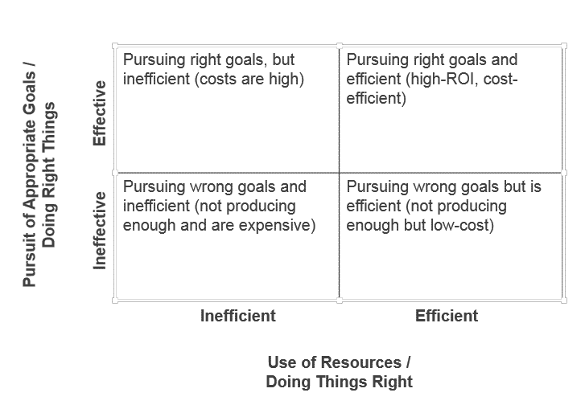Effective (right now) vs. Efficient (long term). Note: ROI stands for return on investment, i.e. what you get out in return for what you put in. (Source: https://www.insightsquared.com/blog/effectiveness-vs-efficiency-whats-the-difference/)
Dare to be different
To make change, we need to change things!
You will find throughout this program that your methods become different from many people around you. However, we encourage you to think with a critical lens. Ask yourself whether the methods we teach you seem valid and logical. Experience the effects yourself and come to your own judgment.
Common does not mean correct.

Sublesson
- Tips and tricks trap
- Tips and tricks trap

Tips and tricks
Learning to learn in the 21st Century
Social media algorithms promote tips and tricks that can be understood in 30 seconds. Unfortunately, social media algorithms do not care about helping you become a better learner. Falling into a trap of tips and tricks can create the perfect recipe for long-term failure.
Thinking critically about "tips"
Tips and tricks are easy and popular. So, if they worked well, shouldn't everyone be a great learner?
4.Common traps
The danger of traps
"Traps" refer to behaviours and tendencies that cause massive damage and harm. While there are not many single techniques that are so powerful that they completely transform your learning by themselves, traps can be so harmful that even one of them can make all of your hard work and "right methods" useless!
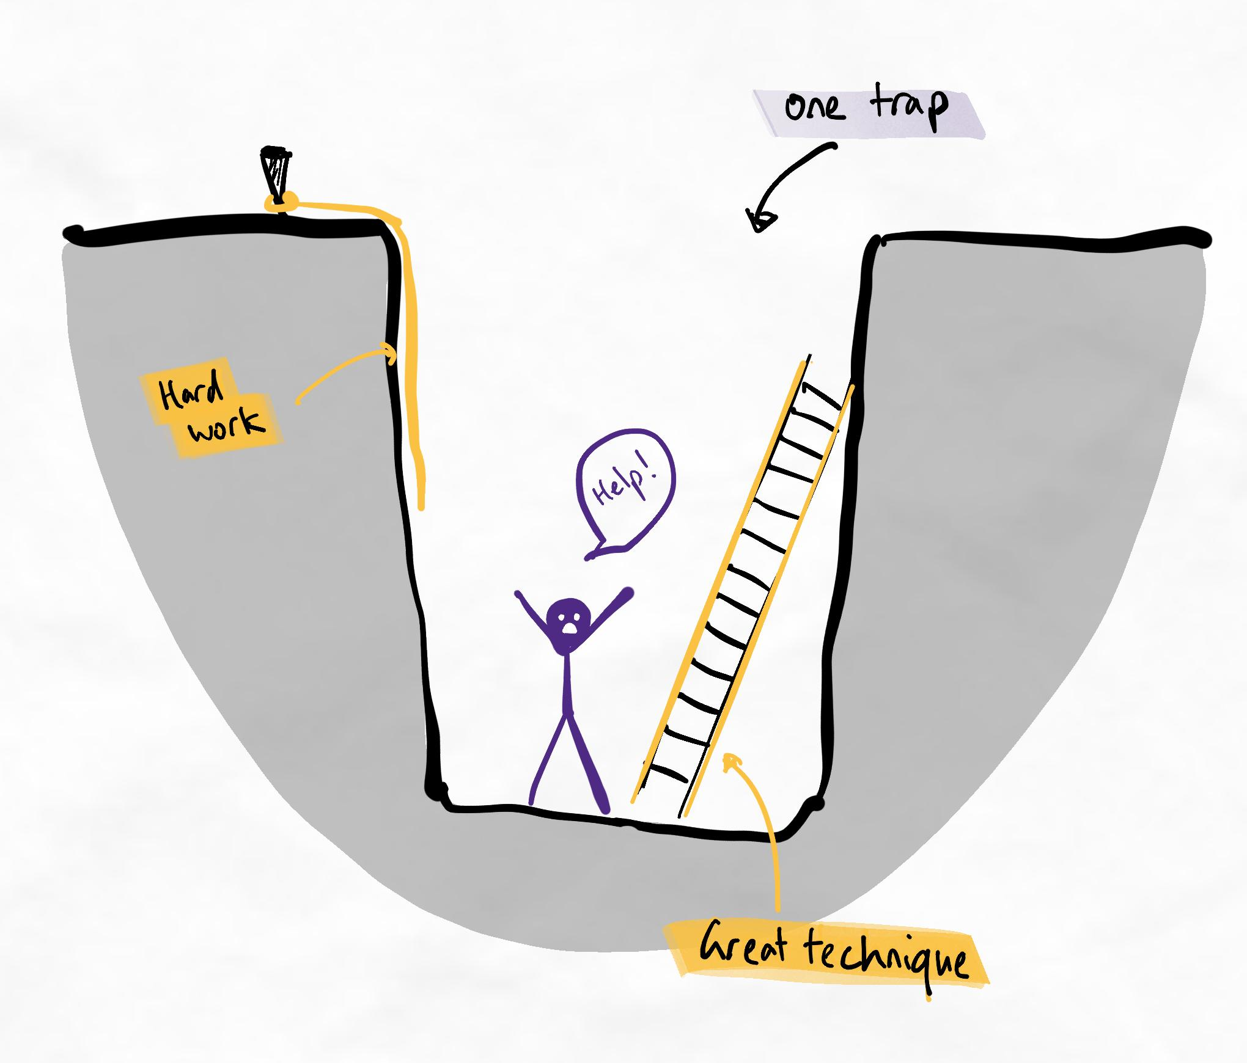One trap can cause disproportionate harm.
Alert
This lesson is considered high-yield. Many learners struggle with improving due to these three issues. We recommend that you pay careful attention to catch yourself.
The three most common traps
These common traps are behaviours and patterns that cause many learners to waste energy with minimal benefit.
The traps are...
- Deathly spirals
- Bandwagon fallacy
- Misfitting techniques
Explanations
Deathly spirals
This happens when you use a technique that helps in the short term but harms you long-term. The most dangerous part is the deeper you fall, the less time and opportunity you have to escape! The best approach is to avoid these entirely. I’ll warn you about possible spirals throughout this program.
These can create something we call learning debt. This is where your future self must do extra work to pay for inefficiencies in your current methods. Because your future self will probably be even busier than you are now, this creates a high chance of being increasingly overwhelmed as time passes.
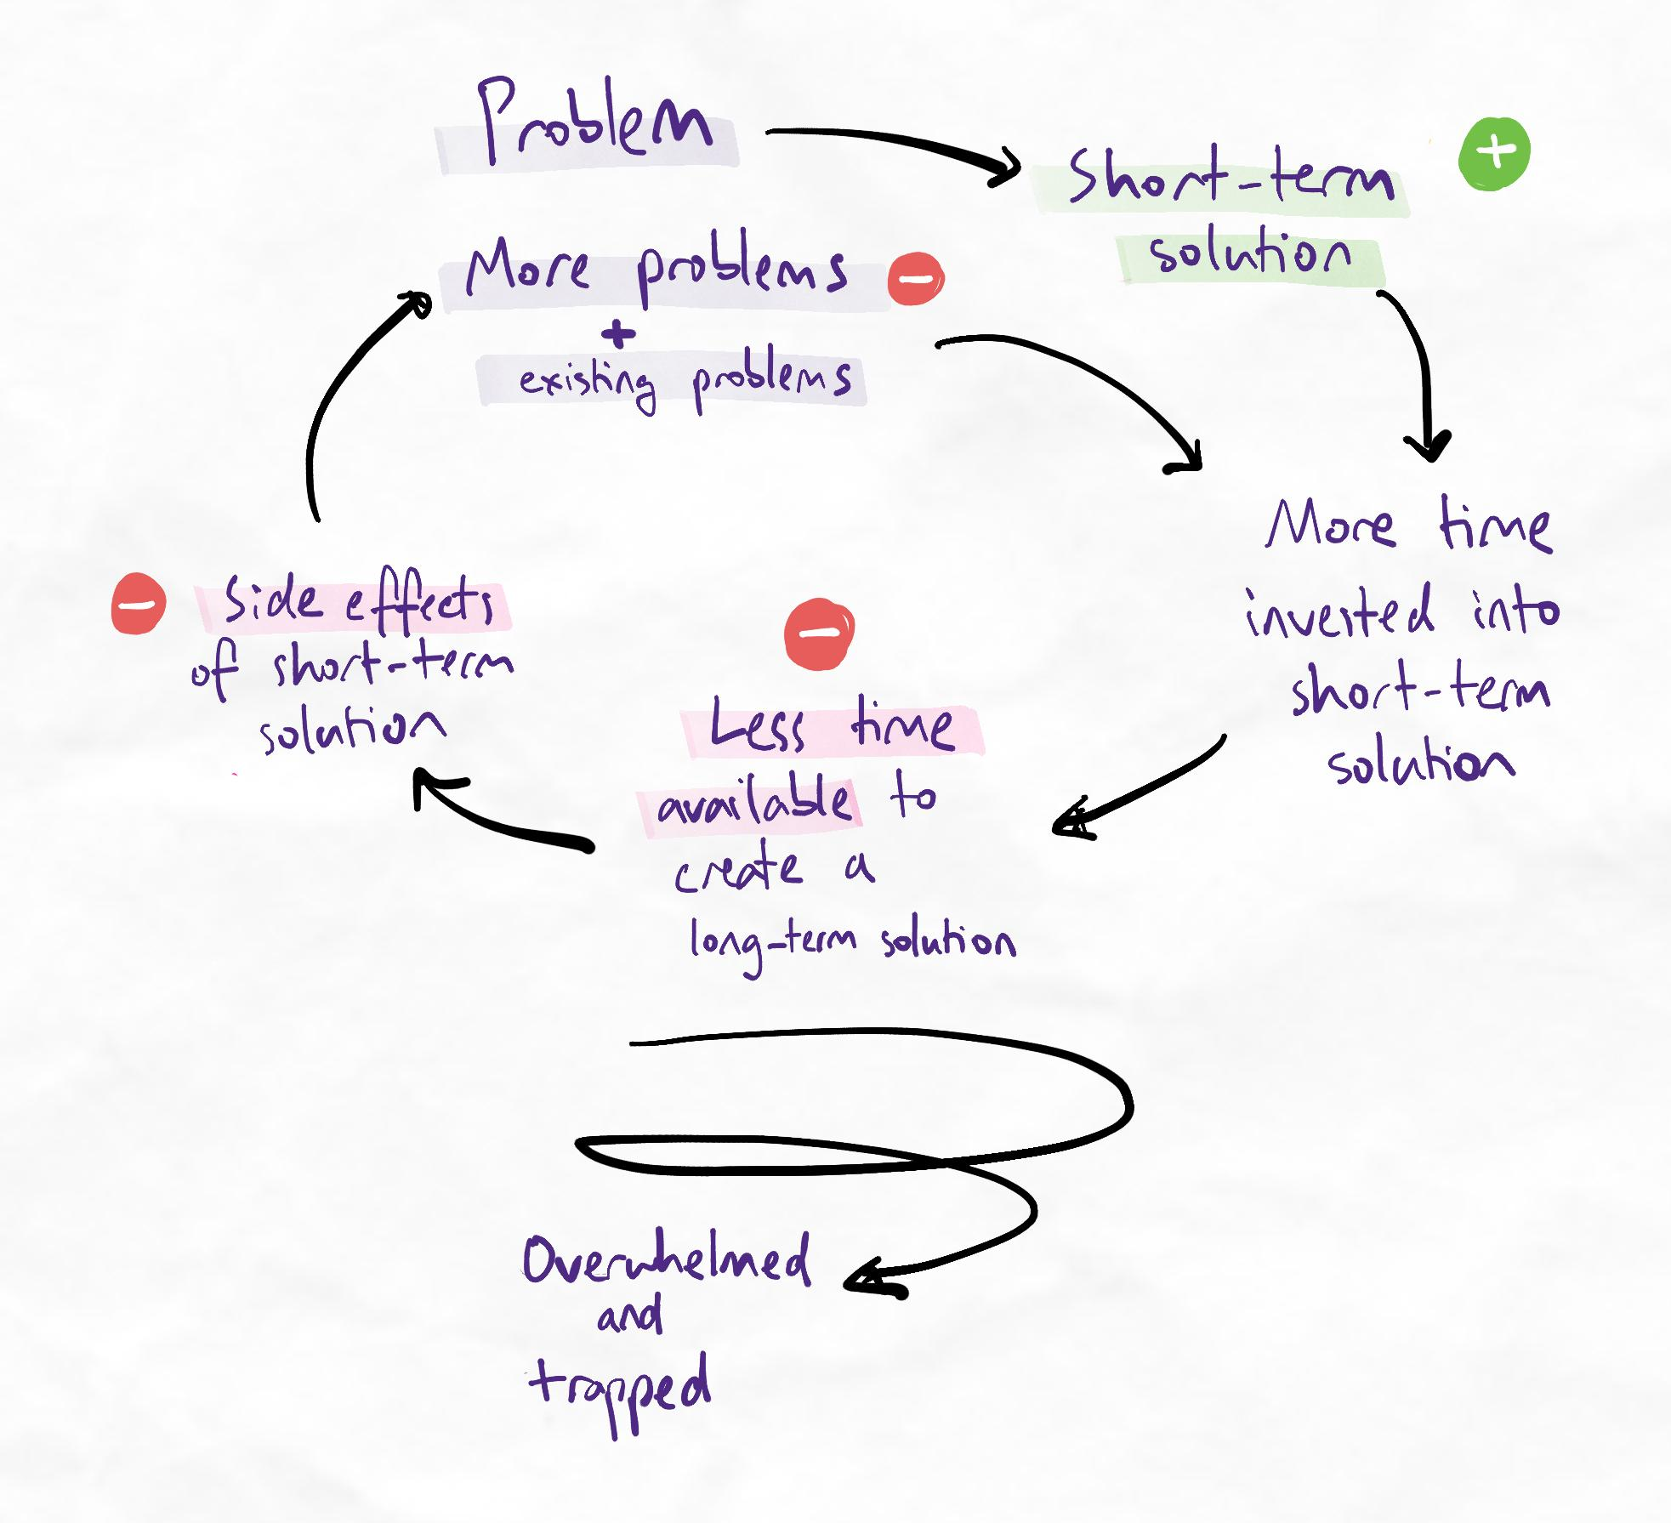The negatives of investing in a short-term solution far outweigh the positives.
A common deathly spiral is not having enough time to work on learning skills because there is too much time spent on learning using ineffective methods. Using ineffective methods helps short-term because (although ineffective) it addresses your immediate need to "cover content". However, long-term, having inadequate skills to tackle the volume or complexity of learning will force a no-win scenario where the only options are to fail or give up.
Bandwagon fallacy
This happens when you use a technique just because other people do. If a technique is common, that doesn’t mean it’s good.
This can be insidious because common methods are often the ones many successful people use. However, amazing athletes don't necessarily make amazing coaches. Successful people often do not know what contributed to their success. In addition, people who failed with the same methods are often much less vocal and public about their failures.
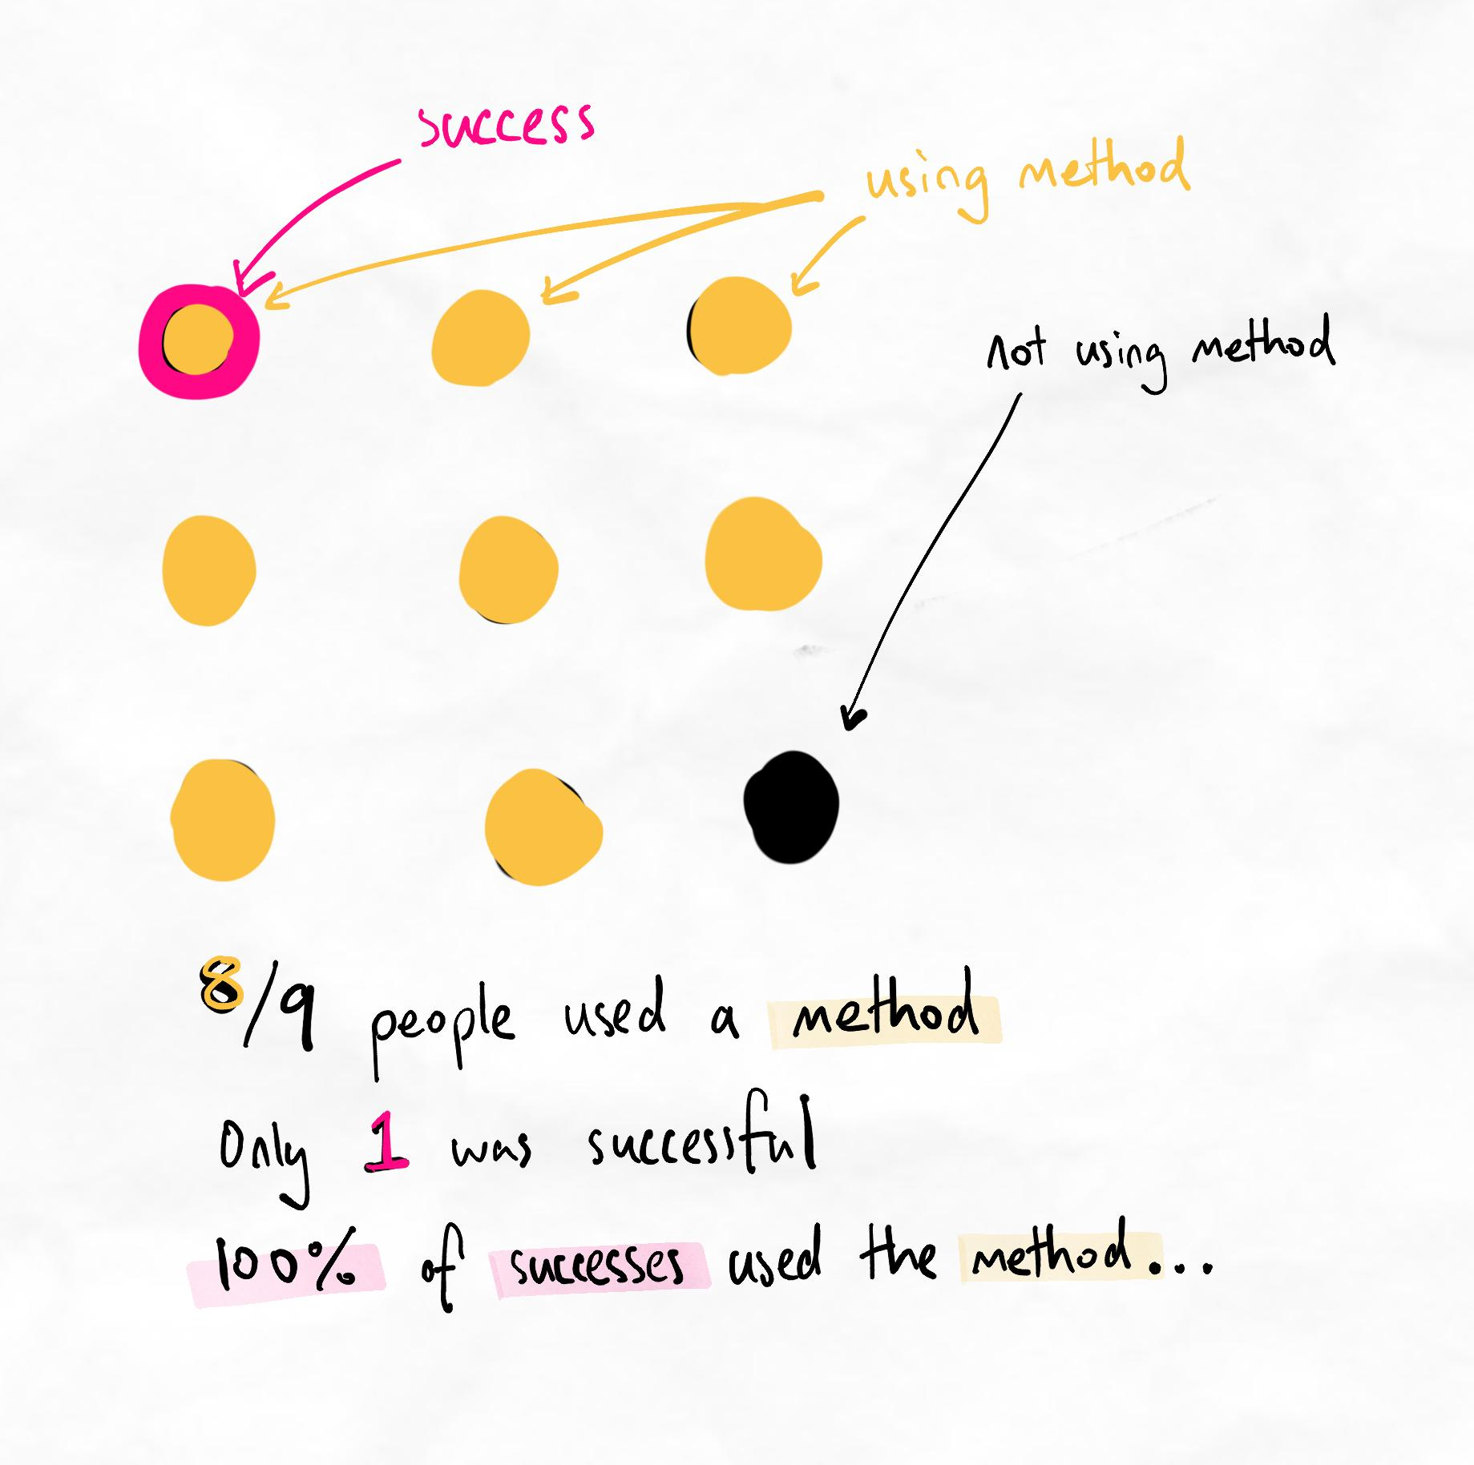Copying success can be dangerous because we often don't know who was unsuccessful with the same methods.
To understand if a method is effective or not, we must know:
- Who used the method and was successful?
- Who used the method and was unsuccessful?

Misfitting techniques
This happens when you use techniques incorrectly or in the wrong situation. The right technique often makes short work out of the problem. If you need substantial effort with a method and it isn’t giving you results, it might not be the right solution. We will also make these situations clear throughout the program for the techniques we teach.
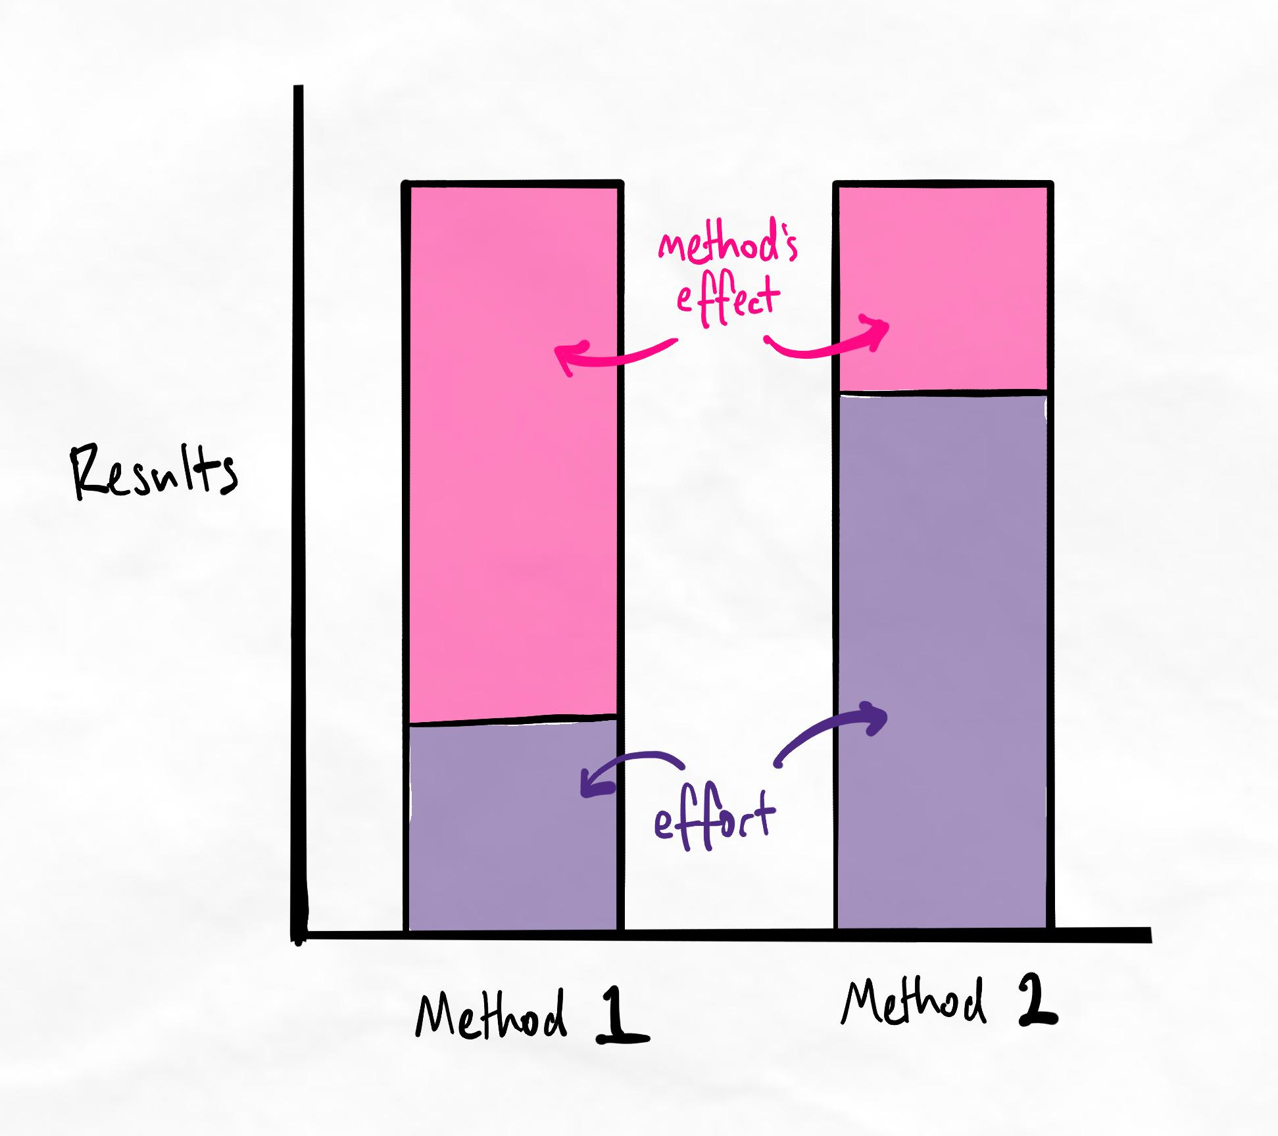If the only way to achieve results is with high effort, our methods need to be evaluated.
In the diagram above, you can see that method 1 requires much less effort than method 2 to achieve the same result. This means that method 1 is a superior approach to achieving the desired result.
When we increase our efforts using method 1, we can also achieve even greater results. On the other hand, when we increase our efforts using method 2, we may be unable to improve by much as the method itself limits us.
Flashcard overreliance: The perfect storm
Flashcards (especially using apps) have taken the world by storm. They have a cult-like following in some circles. Flashcards are useful for creating easier spaced retrieval schedules and utilising micro-learning (a form of learning where sessions are only a few minutes long).
However, overreliance on flashcards (due to bandwagon fallacy) can directly create a misfitting technique and a deathly spiral!
How flashcards can become deadly
- A system is created that increases dependence on more flashcards
- It creates learning debt by relying on your future self to do more repetition to cover the material
- It struggles to create knowledge networks, which results in poor memory and superficial understanding
- This increases the need for more repetition and other methods to fill gaps in depth or complexity of knowledge
- There is less time available to use other methods of learning (or even learn about other methods)
- Every day, more cards accumulate, which increases the level of sacrifice needed to escape the spiral
Fun fact: Software developers are usually not educators
As internationally recognised learning experts, we are invited to advise some of the world's most popular learning software companies on their products.
Unfortunately, what we see behind the curtain is shocking. In our experience, most learning software developers have minimal learning expertise in their team and there is a high resistance to engaging with our advice as it impacts the profitability of their business model.
5. Must do's
Now that we’ve learned some must-nots, let’s look at some must-do’s. Complete the sublessons below to complete this lesson!
Sublessons:
- Prestudy
- Revision
- Focus
- Techniques in school

i.Prestudy
The power of prestudy
Prestudy helps ensure you are on the right path at the beginning, which makes a significant difference throughout the rest of your learning. Fixing your prestudy can automatically fix more complicated issues down the track, saving a lot of time and effort.
How does this work?
Random information is often harder to remember than relevant information that is meaningful to you. This is because your brain recognises the importance of the information and is willing and able to store it more readily. This increases your retention and speed of recall.
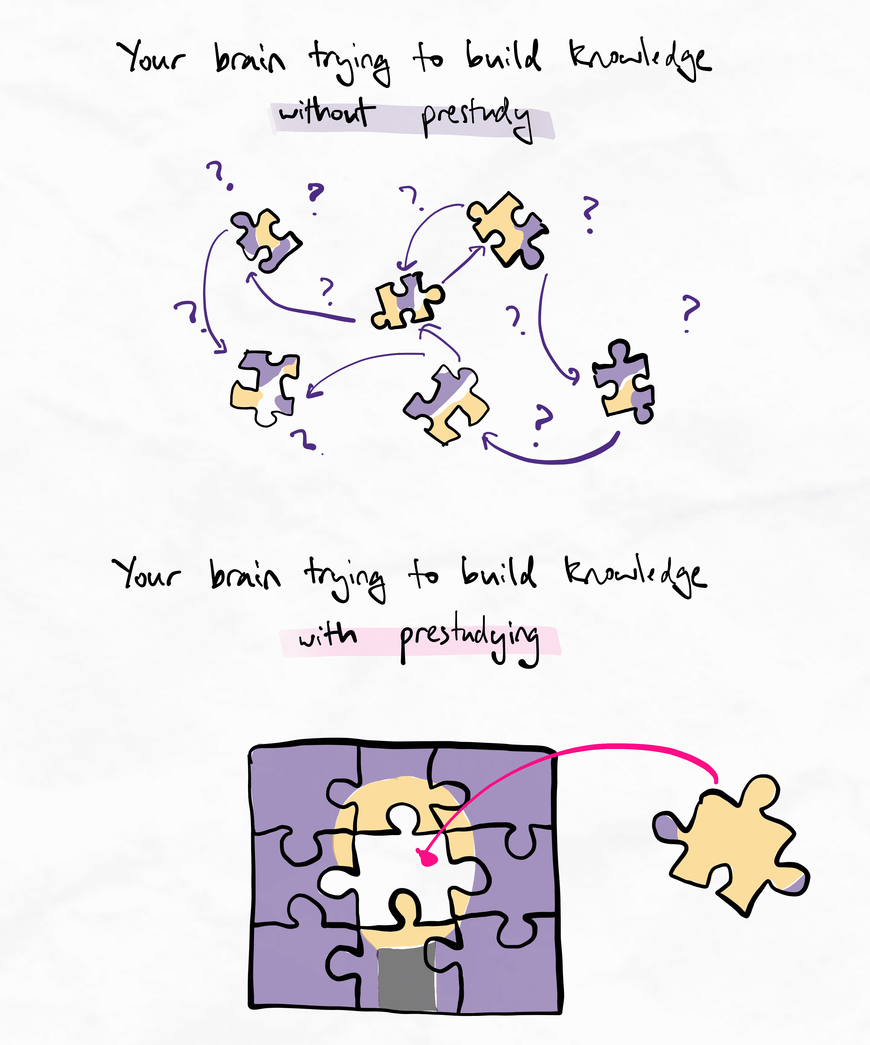Good prestudying helps your brain think by giving new information a place to fit.
Prestudy creates an outline for your brain to fill in later.
Principles of effective prestudy
Whenever you do any prestudy, follow these principles to ensure you're getting the most out of it:
- Group information based on how the information is related
- Focus on the big picture - details can come later
- Spend more time thinking about why something is important or relevant, instead of just trying to remember or understand it
- Try to create analogies and connect the information to what you already know
- Study the entire topic rather than individual classes or lectures so that you can see the full scope of relationships
- Aim to be shallow and broad, rather than deep and narrow
New terminology: Chunking
The process of taking lots of information and putting it in groups is called chunking. We will refer to “chunks” (big groups), “sub-chunks” (groups within groups) and “chunking” (grouping) throughout the program.
Common questions
See our guide here on how to prestudy for a list of common questions and more explanations on some of the nuances of prestudying. We will revisit the concept of prestudying in future lessons as we teach you more techniques as well.

Video references
The study on photography by a university professor is in the book, Art and Fear, Quantity Always Trumps Quality.
Here is a summary by James Clear, one of the world’s leading authorities on practical habit building.
  - Revision
Recap
We've covered these principles before. This is an opportunity to check your system and ensure you're continuing to do your interleaved retrieval sessions.
The most basic principles of effective revision are to:
- Schedule your revision: Have one weekly revision and one monthly revision. This is a very basic form of a learning strategy known as spaced repetition.
- Use full recall: Before you open your notes or textbook, try to recall the information first, using various methods such as writing, drawing, mindmaps, teaching someone else, or asking and answering practice questions.
Feeling confident with revision and SIR?
If you've been practising and feel confident, now is a good opportunity to experiment with other interleaving levels.
You may have skipped a lot of techniques in the Interleaving table because it was overwhelming at the time. No problem! Have a look at it again and see what you can experiment with.
  - Focus
Elements of focus
To focus is to concentrate deeply on a task and shut out distractions. It enables you to achieve more within a given time than someone who lacks focus. Here are some points to help you create and maintain focus:
- Sleep: You must protect your sleep. In general, aim for at least 8 to 9 hours of sleep. Sleep has dramatic carry-over effects on focus, energy, mood, and sleep-dependent memory consolidation (a critical learning phenomenon).
- Remove distractions: Before you start a focused work session, spend time removing all possible distractions. Remember to use your distraction cheat sheet to note down everything that distracts you, and make sure to remove all of those things at the beginning of your next study session.
- Breaks: Have breaks more often, but keep them short (i.e. high frequency, low duration). This is because our body recovers faster when it is less exhausted. Frequent, shorter breaks allow for longer overall focus throughout the day – so it’s better to have a 20 to 30-minute study session and a 5-minute break than to study for 4 hours and have a 1-hour break. To keep the length of your break under control, use a timer set to 5, 10 or 15-minute intervals.
We will add more advanced variations of these techniques later in the course.
iv. Techniques in school
Optional
This sublesson is for those in school. If the advice on this page is not relevant to you, feel free to move onto the next sublesson. Note that some of the techniques in this sublesson may still be useful and transferrable for many other contexts.

Many students have expressed that it is difficult to use some of our techniques at school. Often, this is because the teacher enforces or advises students to use particular techniques.
Although their intentions are generally good, mainstream teacher training does not have much focus on learning science. As such, the techniques enforced by teachers can be outdated or anecdotal. Sometimes, their recommendations can be detrimental to students’ short-term and long-term learning.
General rule
Generally, if our advice on learning conflicts with what you hear from school, we recommend following our advice instead.
Most teachers do not have the time and freedom to become specialists in learning skills. As leaders in this industry, we continue to work with schools and institutions globally to help train teachers with the latest research and practice observations.
How to use our methods in class

If your teacher does not allow you to use our techniques in class or overwhelms you with homework, you can try these approaches:
- Discreetly use the technique anyway. This is the easiest solution. Your teacher may force you to write linear or passive notes, but if they aren’t checking, you could get away with using our techniques anyway. If you can do your own work or study your own way in class without being detected by the teacher, do so.
- Do the minimum possible to satisfy your teacher. If the above isn’t an option, spend as little time as possible on unweighted assignments or homework so you have more time for proper self-study. The “time-boxing” approach below may be useful here.
- Use class as a way to revise the material and find gaps. When sitting in class, instead of just trying to absorb information, you can use class as a dynamic quizzing environment. Actively look for things you aren’t clear about, or ask deeper and more detailed questions you usually wouldn’t think about. This is a common strategy for university students who are doing effective prestudy.
- Do your homework during class. Most of the time, homework is just about finishing questions. If you have already learned the material or find it easy, you can do the homework during class.
Time-boxing

Unlike time-blocking, which is a time management technique that involves scheduling blocks of time in your schedule to complete work, time-boxing is when you do not exceed the amount of time blocked out.
For example, if you schedule one hour to complete something, time-blocking allows room for flexibility. Time-boxing dictates that at the end of one hour, your time is up.
Time-boxing is a useful method for completing work that is either very important or very unimportant (but compulsory).
For very important tasks
Many important tasks are not urgent. For example, improving your learning skills may be important but not urgent. These tasks can not usually be completed in a single 'session' anyway. Therefore, time-boxing is useful because it allows you to commit time to making progress on life-changing, important activities.
For very unimportant (but compulsory) tasks
For tasks without any real consequence but are mandatory to complete, time-boxing gives you enough time to complete them to a sufficient standard without wasting time beyond its value.
The best example is homework that does not contribute to your final grade. You need to do these tasks for school, but they aren’t as important as doing well in actual exams or tests, so you shouldn’t spend too much time on them.
How to time-box your homework
- Assign the amount of time you need for important tasks such as self-study or working through this course. These are truly important tasks and should not be compromised.
- Schedule this time into your day or week.
- Allocate some of your remaining time for unimportant tasks like unweighted homework. This may be less time than you are used to spending on those tasks.
- Complete your unimportant tasks as quickly as possible within the allocated time.
The idea is not to get a perfect outcome but the best outcome in the time available (sometimes, we refer to this as the best-for-time outcome). This approach can also help to combat perfectionist tendencies.
Principles related to time-boxing
Parkinson's law
This suggests that an activity will contract or expand to fill the time available. Give yourself lots of time, and it will take lots of time. Give yourself very little time, and you will still get it done (within reasonable limits).
Pareto principle
Otherwise known as the 80:20 rule, this states that 80% of an effect resides in 20% of the work or input. For example, 80% of your learning occurs due to 20% of the information (this is a powerful phenomenon that we will heavily exploit later), 80% of your time is wasted on 20% of distractions, and 80% of your essay is written in 20% of the total time.
Eisenhower matrix
This prioritisation framework indicates how unimportant but urgent tasks might be handled.
Alternatively, negotiate (maybe)

If you feel your teacher is open to the idea, you may wish to openly discuss the techniques and methods you are trying to use and ask for permission.
In cases where students have shown they have an excellent level of knowledge and are ahead of the class, some teachers have even issued a “hall pass” to students, allowing them to not come to class and instead self-study in the library or do their own revision during class time.
Last resort
If all else fails and you have to sit in class, learning nothing new, and are unable to self-study discreetly we can try to reduce our quantity of prestudy so class is more engaging.
In essence, we are deliberately increasing the level of confusion we would feel in class by having a less comprehensive and even shallower level of prestudy. The idea is that if you must attend class anyway, this is time that we would otherwise waste. By loading class time with more cognitive load instead of during prestudy, we make the class more challenging and, therefore, more engaging.
We can then devote the self-study time we would have spent on deeper prestudy on interleaved retrieval instead.
Alternatively, the other option is to stay ahead of the class and accept that class is boring. Perhaps you can practise some mindfulness meditation?
Either way, remember that feeling bored in class because you're so ahead of the material and you already know so much is a great problem to have!
Learning self-diagnosis

Back to stage
Putting it together
Some learners find it difficult to schedule all their studying sessions throughout the week.
Therefore, we've created some example schedules that you can use for typical school or lecture timetables. These schedules have been tried and tested across thousands of students and are safe templates for you to base your own schedules around.
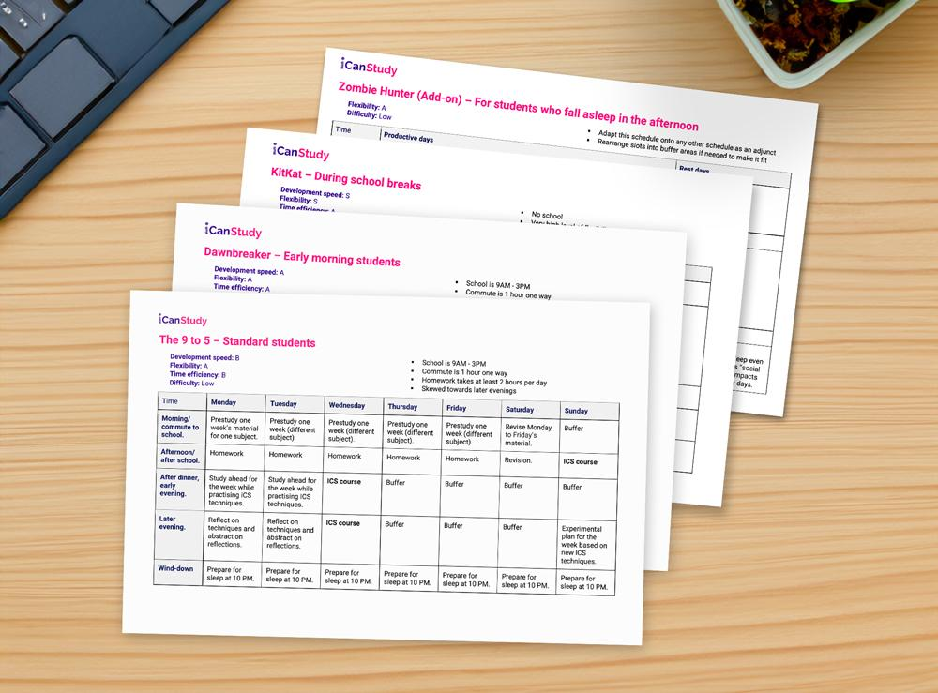
Each schedule includes a prestudy and revision routine and is rated on:
- Development speed: How quickly you would be able to learn the skills in this program
- Flexibility: How easily you can adapt to changes in your schedule
- Time efficiency: How effectively the schedule maximises available time to produce meaningful work
- Difficulty: The complexity of trying to follow the schedule

Table of contents
Quiz: Self-diagnosis quiz
Sublessons:
- Story of Sam
- Logical alignment
- Confidence
- Gear checklist

Quiz: Self-diagnosis quiz

Question 1
Regarding effective learning, select the most correct statement:
A learning system depends on both efficient encoding and adequate retrieval.
A learning system depends on efficient encoding. Retrieval is optional.
A learning system depends on significant retrieval. Encoding efficiency does not make a big impact.
Ans: A learning system depends on both efficient encoding and adequate retrieval.

Regarding effective learning, select the most correct statement:
Methods for learning (either during encoding or retrieval) can be considered effective when they help me to learn faster and more easily.
Methods for learning (either during encoding or retrieval) can be considered effective when they help me to cover more content in the same amount of time.
Methods for learning (either during encoding or retrieval) can be considered effective when they promote certain types of difficulty and effort.
Ans: Methods for learning (either during encoding or retrieval) can be considered effective when they promote certain types of difficulty and effort.

Regarding effective learning, select the most correct statement:
Processing information efficiently while learning is about understanding each new piece of information fully.
Processing information efficiently while learning involves thinking about how new information fits into the big picture.
Processing information while learning depends on finding as many relationships as possible and mapping them all out.
Ans: Processing information efficiently while learning involves thinking about how new information fits into the big picture.

Question 2
Regarding SIR, select the most correct statement:
Efficient spacing means testing ourselves with retrieval as infrequently as possible to give each retrieval session the maximum level of challenge.
Efficient spacing means testing ourselves with retrieval as frequently as possible to minimise how much we forget.
Efficient spacing means testing ourselves with retrieval frequently enough that we do not forget too much, but with enough of a gap that we are challenging ourselves.
Ans: Efficient spacing means testing ourselves with retrieval frequently enough that we do not forget too much, but with enough of a gap that we are challenging ourselves.

Regarding SIR, select the most correct statement:
Retrieval practice is ideally performed through natural work challenges and experiences, where knowledge must be applied in real settings.
Retrieval practice is ideally performed in dedicated learning sessions.
Retrieval practice is ideally performed through a combination of natural work applications and dedicated learning sessions.
Ans: Retrieval practice is ideally performed through a combination of natural work applications and dedicated learning sessions.

Regarding SIR, select the most correct statement:
Different types of knowledge and topics require different interleaving methods.
A good interleaving system allows you to cover all of your needs for most topics using the same methods.
Efficient interleaving is about finding the one or two methods that are the most effective for you through experimentation.
Ans: Different types of knowledge and topics require different interleaving methods.

Regarding skill improvement, select the most correct statement:
The fastest and safest way to improve skills is to make as many mistakes as possible, as quickly as possible.
The fastest and safest way to improve skills is to make frequent mistakes, early on with frequent critical reflection.
The fastest and safest way to improve skills is to understand new methods and techniques as deeply as possible to remove any uncertainty before attempting to use the skill.
Ans: The fastest and safest way to improve skills is to make frequent mistakes, early on with frequent critical reflection.

Regarding skill improvement, select the most correct statement:

Kolb's leads to marginal gains that compound positively over time. Without Kolb's, marginal gains could fluctuate or be negative.
Marginal gains compound positively over time. Kolb's allows it to compound more quickly.
Kolb's leads to positive marginal gains when experiments are reflected on in new cycles. Without this, marginal gains may not positively compound.
Ans: Kolb's leads to positive marginal gains when experiments are reflected on in new cycles. Without this, marginal gains may not positively compound.

- Story of Sam
Sam's story
Can you relate to Sam's story?
Hearing other people’s situations, whether similar or different, often helps in our own personal situations. Although you may wish to transform your skills immediately, remember that some things cannot be rushed (otherwise, everyone would do it)!
Our philosophy
People often underestimate how deep and complex learning skills can be because they are rarely exposed to real learning science. The process of trying to improve is also confusing and sometimes frustrating! Over the years, we've refined our program to make it easier and more achievable than it has ever been. But it still doesn't make the journey easy.
We've realised that difficulty is an unavoidable part of the growth. Rather than try to remove discomfort, which may be impossible, we focus on teaching you the skills and mindsets to embrace discomfort and thrive.
True empowerment is more than feeling comfortable
We believe this is true empowerment: the ability to not only succeed when it is easy but to face challenges and overcome uncertainties when most others cannot.

ii.Logical alignment
Logical alignment
The essence of self-regulated learning
We must be able to control our studying to overcome unpredictable obstacles safely. Sam struggled because his learning methods were ineffective, and he could not make the necessary adjustments.
In this lesson, we’ll go through three major components that form a learning triad: cognition, notes and revision. For you to reach your learning goals, these three components must logically align.
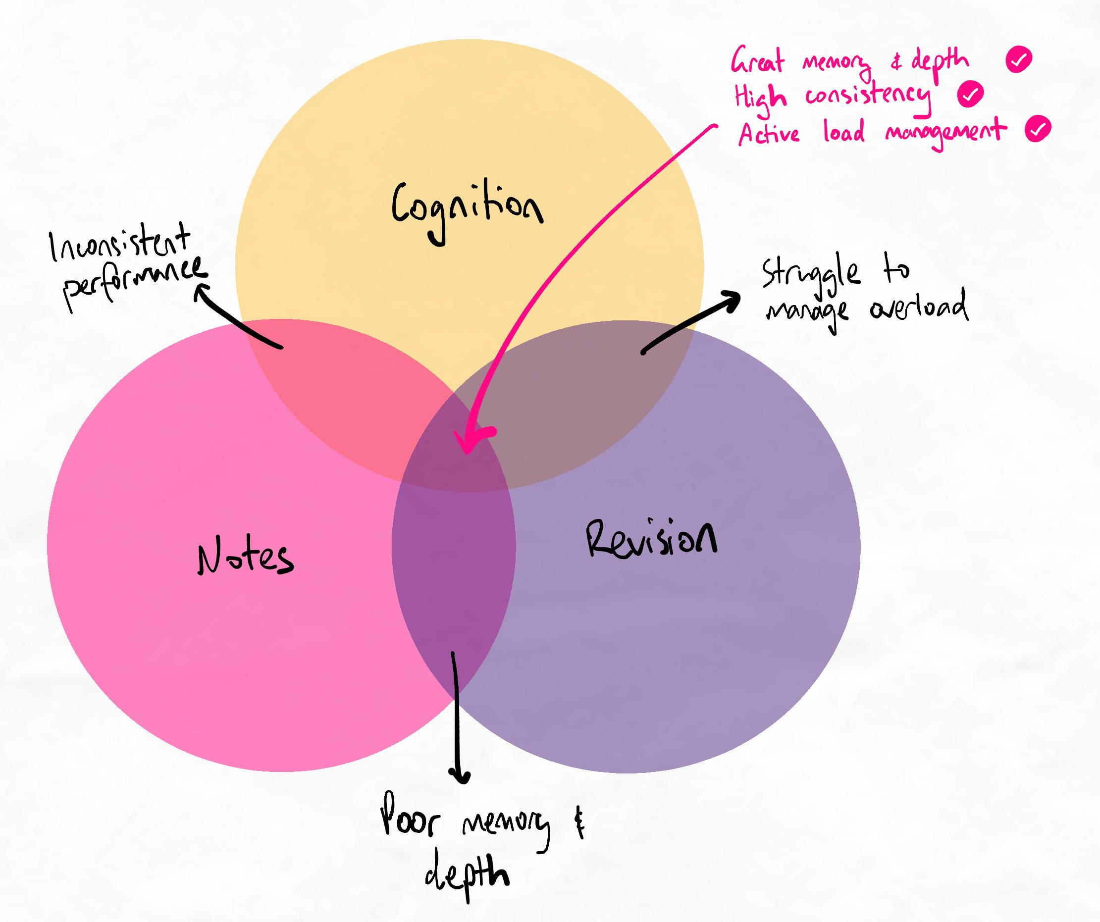All three must be aligned to have a problem-free learning system.
Refer to these major components whenever you want to do a rapid assessment of your learning methods.
Analogy
It’s like playing an instrument. You need the right know-how (cognition), a good technique so you can practise and improve (notes) and a good ear to pick up on mistakes (revision). If you were missing even one of these, you would struggle to become an expert musician!
The learning triad

Cognition
Aligned cognition means that the thinking processes involved in learning must be effective. This involves:
- Having active learning that uses energy and effort the right way
- Forming connections and relationships by comparing and contrasting
- Making sense of information by simplifying and grouping it
- Connecting new information with existing information
Sam was very passive. He was unaware of what his brain was doing when trying to learn. This meant he didn’t know what to improve to become more efficient.
Awareness of how we are thinking is called metacognition. High metacognition is one of the strongest predictors of learning success.

Notes
Aligned note-taking means it helps cognition. Information overload is prevented by offloading information into notes. However, note-taking is not so excessive and passive that we use it as a way to stop thinking.
Think of note-taking like solving a jigsaw puzzle:
- You pick up pieces from the box and put them together to form a big picture.
- You can look at the picture you're putting together and compare it to new pieces you pick up.
- It's much easier than trying to connect all the pieces together in your mind (overload).
On the other hand, passive note-taking is like if you were to:
- Mindlessly place every piece you pick up without thinking about where it fits
- As you continue, the picture you form becomes messier.
- There are fewer pieces left in the box (making us feel good), but what you've placed is just as messy, so now you must go through that again to sort it. What a waste of time!
Sam would write very long and linear notes, which is passive and essentially just photocopying text from the teacher or textbook. This leads to very low retention and understanding.

Revision/retrieval
Aligned retrieval means:
- We have spacing
- We are using interleaving purposefully for the right type and order of knowledge
- The methods and frequency of retrieval are suited to our needs
To revise, Sam would repeatedly go through past papers only. He didn’t even know how many papers he needed to do; he fell to the bandwagon fallacy and copied his friend’s way of revising, which was incorrect.

iii.Confidence
The Dunning-Kruger effect
Most people are confident in their studying skills, but studies consistently show that they are usually overconfident, especially in areas where they have a small amount of knowledge. The Dunning-Kruger graph shows a person’s confidence relative to their knowledge.
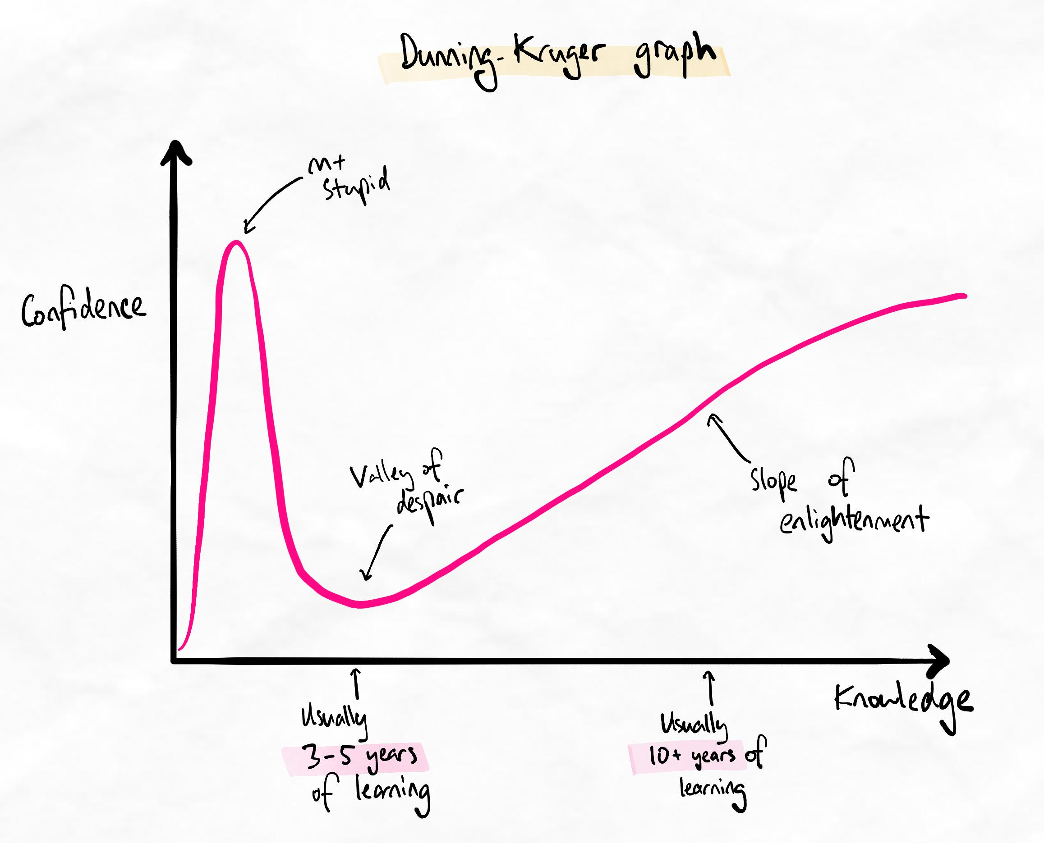Note that there are only two positions where confidence would be high.

Mount Stupid
The first peak is Mount Stupid. This is where people gain a lot of confidence because their knowledge of a new topic has increased quickly. However, in absolute terms, they still know very little because their starting point was nothing! As a result, people at this stage are often confident despite having low levels of knowledge.
Unfortunately, many learners are at this stage, as mainstream education teaches little about learning science.

Valley of Despair
The first dip is known as the Valley of Despair. This is where people realise, after delving deeper into the topic, that there is actually a lot they don’t know. This is typically the stage that PhD candidates are at after studying the topic for 5+ years.

Slope of Enlightenment
The slope of enlightenment is the period where people gain knowledge. This period can last decades and eventually culminates at the peak (when they have mastered the topic).
Confidence is a lie... or is it?
One of the biggest challenges around overconfidence is that we are oblivious to our own ignorance.
If we are unaware of what we don't know, how can we ever know if we are overconfident... or just confident?
One way is to objectively assess our confidence level and time invested into building expertise. Because there are only two points where we have high confidence, we can ask ourselves:
- Do I feel very confident?
- Have I dedicated several years to intensively learning about this to become an expert?
If the answer to the first question is 'yes' and the second is 'no', then we can say we are probably overconfident. What's important to remember is that we still won't feel any less confident. But this doesn't have to dictate how we behave and think.
The wise mind model
In psychology, the Wise Mind model is a popular framework for understanding the "types" of minds humans engage in.
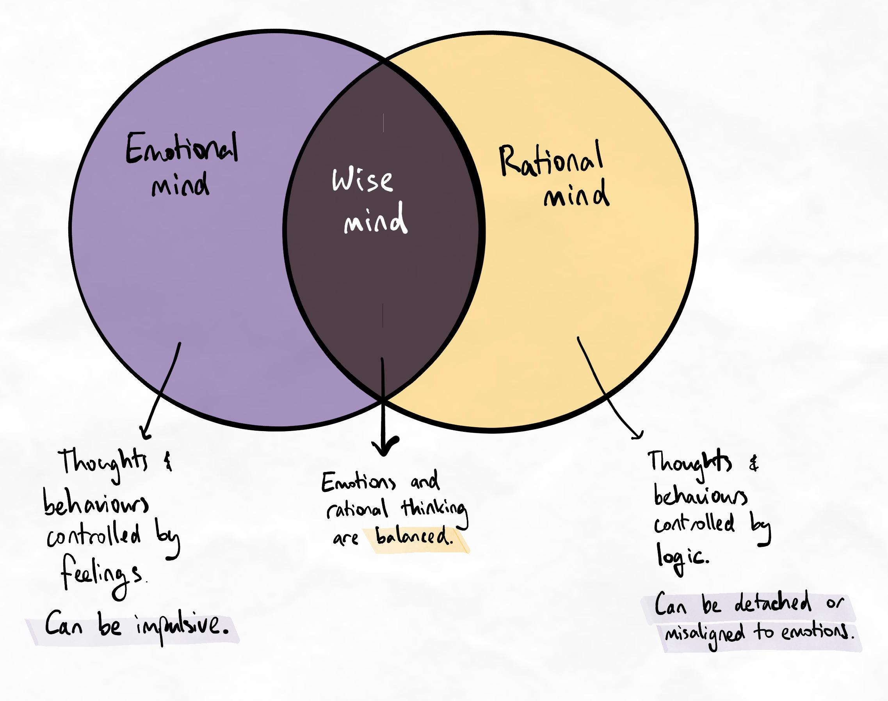The wise mind is when emotions and logic are balanced.
Operating with different minds:
- When we operate with the emotional mind, we are controlled by feelings. Too much emotional mind can cause us to ruminate and spiral. We can panic, become anxious, impulsive, or allow our feelings (such as confidence or motivation) to dictate what we do.
- When we operate with the rational mind, we are controlled by logic and thinking. Too much rational mind can cause us to overanalyse and feel paralysed. It can also cause us to become unhealthily detached from our emotional needs or the needs of others.
Often, the best balance is in between. We can both be in tune with our feelings but let our behaviours and thoughts be guided by what we rationally tell ourselves through our logic and knowledge. This is the wise mind.
Relating the wise mind to overconfidence
We can use these self-assessment questions to identify if we are overconfident. By understanding that we are overconfident, even though we feel justified in our confidence, we can prevent ourselves from engaging in detrimental behaviours.
The ability to use our rational mind to balance our emotional mind and prevent our behaviours and actions from being dictated by only how we feel is a critical skill for emotional and behavioural self-regulation.
Controversy around Dunning-Kruger
Since around 2020, there has been increasing debate around the validity of the Dunning-Kruger effect. The following is some optional reading for those interested in diving deeper into the state of the research.

Against Dunning-Kruger
The arguments against Dunning-Kruger are a valid scientific inquiry, with the most robust positing that all humans are generally susceptible to bias and that bias does not disproportionately affect those with lower knowledge.
This is a contentious point. While we know that bias affects all humans, some research suggests that systems of proactively moderating biases are effective. There is also research around the illusion of competency and the illusion of fluency, which closely parallel the findings from the Dunning-Kruger effect.
In reality, we are likely oversimplifying the relationship between knowledge and confidence. There are plenty of overconfident people who are highly skilled, and there are plenty of unskilled and unknowledgeable beginners who are rightly humble.
On the other hand, many non-researchers are quick to criticise the Dunning-Kruger effect based on their limited knowledge. In reality, only one or two articles are inadequate to form an opinion about the scientific validity of something. Ironically, non-researchers are often on Mount Stupid regarding their view on Dunning-Kruger...

Against the graph
Some people contest the validity of the Dunning-Kruger effect because the graph is not from the original paper. However, proponents of this tend to ignore the empirical support for this graph that has subsequently been observed in a range of studies. We provide some key examples in the references below.

The state of the science
The current state of the science is not conclusive. Based on the current literature, we can say with reasonable confidence that:
- Knowledge and skill level do seem to have an influence on confidence.
- Unlike many other psychological processes, the Dunning-Kruger effect has some neurophysiological evidence that supports the use of different cognitive processes in over or under-estimators.
- The extent and universality of this is not clearly defined, and it seems to vary depending on context.
- Overconfidence seems to be more consistently found for skills than domain knowledge, which varies more significantly between studies.
- The level of over or under-estimation seems to depend on the difficulty and complexity of the task (more complex tasks are more likely to have overconfidence), the actual knowledge and expertise of the person, and the person’s level of personal self-esteem and general self-confidence.
- Peripheral, semi-consilient research on cognitive biases and perceptions of skill and expertise is broadly supportive of a Dunning Kruger pattern.
- Knowing about the Dunning-Kruger effect can be protective for it.
The final point is incredibly important and is one of the most recent findings – i.e. that teaching someone about Dunning-Kruger can be enough to statistically eliminate it from some empirical studies.

Our experience
In our own experience, we have strongly found that new members who are overconfident have a massively higher proportion of technique error compared to students who are:
- Intuitively overconfident, but moderate themselves and force humility and open-mindedness; or
- Intuitively underconfident and doubt their abilities.
By far, the worst results received by our students are from overconfident beginners, who are usually overconfident because they have achieved prior academic success using their old techniques.
While the old techniques that worked well for them were usually quite valid, we’ve found that overconfidence can prevent them from changing the parts that didn’t work or are holding them back. In many cases, this unwillingness to change or modify techniques causes barriers to further improving their techniques in later stages, where many component skills must be mastered before we combine them into an advanced version.

References
Acosta, G., Smith, E., & Kreinovich, V. (2020). Analytical Techniques for Gauging Accuracy of Expert Knowledge: A Simple System-Based Explanation of the Dunning–Kruger Effect. In Towards Analytical Techniques for Systems Engineering Applications (pp. 27-32). Springer, Cham.
Burson, K. A., Larrick, R. P., & Klayman, J. (2006). Skilled or unskilled, but still unaware of it: how perceptions of difficulty drive miscalibration in relative comparisons. Journal of personality and social psychology, 90(1), 60.
Coutinho, M. V., Thomas, J., Alsuwaidi, A. S., & Couchman, J. J. (2021). Dunning-Kruger Effect: Intuitive Errors Predict Overconfidence on the Cognitive Reflection Test. Frontiers in psychology, 12, 1040.
Dunning, D., Heath, C., & Suls, J. M. (2004). Flawed self-assessment: Implications for health, education, and the workplace. Psychological science in the public interest, 5(3), 69-106.
Ehrlinger, J. (2008). Skill level, self‐views and self‐theories as sources of error in self‐assessment. Social and Personality Psychology Compass, 2(1), 382-398.
Ehrlinger, J., Johnson, K., Banner, M., Dunning, D., & Kruger, J. (2008). Why the unskilled are unaware: Further explorations of (absent) self-insight among the incompetent. Organizational behavior and human decision processes, 105(1), 98-121.
Feld, J., Sauermann, J., & De Grip, A. (2017). Estimating the relationship between skill and overconfidence. Journal of behavioral and experimental economics, 68, 18-24.
Gignac, G. E. (2022). The association between objective and subjective financial literacy: Failure to observe the Dunning-Kruger effect. Personality and Individual Differences, 184, 111224.
Gignac, G. E., & Zajenkowski, M. (2019). People tend to overestimate their romantic partner’s intelligence even more than their own. Intelligence, 73, 41-51.
Gignac, G. E., & Zajenkowski, M. (2020). The Dunning-Kruger effect is (mostly) a statistical artefact: Valid approaches to testing the hypothesis with individual differences data. Intelligence, 80, 101449.
Jansen, R. A., Rafferty, A. N., & Griffiths, T. L. (2021). A rational model of the Dunning–Kruger effect supports insensitivity to evidence in low performers. Nature Human Behaviour, 5(6), 756-763.
Kruger, J., & Dunning, D. (1999). Unskilled and unaware of it: how difficulties in recognizing one’s own incompetence lead to inflated self-assessments. Journal of personality and social psychology, 77(6), 1121.
Mata, A., Ferreira, M. B., & Sherman, S. J. (2013). The metacognitive advantage of deliberative thinkers: A dual-process perspective on overconfidence. Journal of personality and social psychology, 105(3), 353.
McIntosh, R. D., Fowler, E. A., Lyu, T., & Della Sala, S. (2019). Wise up: Clarifying the role of metacognition in the Dunning-Kruger effect. Journal of Experimental Psychology: General, 148(11), 1882.
Motta M, Callaghan T, Sylvester S: Knowing less but presuming more: Dunning-Kruger eﬀects and the endorsement of anti-vaccine policy attitudes. Soc Sci Med, 2018; 211: 274–81
Moore, D. A., & Healy, P. J. (2008). The trouble with overconfidence. Psychological review, 115(2), 502.
Moore, D. A., & Small, D. A. (2007). Error and bias in comparative judgment: on being both better and worse than we think we are. Journal of personality and social psychology, 92(6), 972.
Muller, A., Sirianni, L. A., & Addante, R. J. (2020). Neurophysiological correlates of the Dunning-Kruger effect. bioRxiv, 2019-12.
Pennycook G, Ross RM, Koehler DJ, Fugelsang JA: Dunning-Kruger eﬀectsin reasoning: Theoretical implications of the failure to recognize incompetence. Psychon Bull Rev, 2017; 24(6): 1774–84
Simons DJ: Unskilled and optimistic: Overconﬁdent predictions despite calibrated knowledge of relative skill. Psychon Bull Rev, 2013; 20(3): 601–7
Sullivan, P. J., Ragogna, M., & Dithurbide, L. (2019). An investigation into the Dunning–Kruger effect in sport coaching. International Journal of Sport and Exercise Psychology, 17(6), 591-599.
Tan LT: Innovations in continuing professional development – countering the Dunning-Kruger eﬀect. Clin Oncol, 2011; 23(10): 659–61
Zawadka, Mateusz & Graczyńska, Agata & Janiszewska, Anna & Ostrowski, Andrzej & Michałowski, Maciej & Rykowski, Michał & Andruszkiewicz, Paweł. (2019). Lessons Learned from a Study of the Integration of a Point-of-Care Ultrasound Course into the Undergraduate Medical School Curriculum. Medical Science Monitor. 25. 4104-4109. 10.12659/MSM.914781.
Note that this list of references is not a comprehensive review of all the relevant literature. It is just some of the supporting research for the statements made in this single lesson.

iv.Gear checklist

Are you ready?
Let’s run through our current system and make sure we’re happy with our cognitive “equipment” before moving on. After all, only a fool would try to climb a mountain with a ripped harness and broken clips!
Gear checklist
By the end of this lesson, we would expect that you have met each of the outcomes listed below. Expand each item to read through the outcomes. If there are any outcomes you have not yet reached, we recommend practising those before progressing.

General competence
Deep processing
- You are gaining experience with finding similarities and differences between information, grouping them, and gaining a big-picture understanding.
- You have familiarity with the discomfort and confusion involved in trying to find the right groups and express them with non-linear note-taking. Your tolerance for this discomfort is slowly starting to improve.
Self-regulation
- You are developing an awareness of how different cognitive processes and methods of learning affect your memory, learning experience, and quality of knowledge.
- You are beginning to understand how difficulties in learning can be desirable.
- You have some experience with modifying your learning system to achieve different results and effects.
Retrieval
- You are using SIR and developing competence with at least three interleaving methods
- You are developing greater awareness for how different types of knowledge and different orders of learning require different types of thinking and practice.
Mindset
- You have experience with experimenting with different learning methods and learning from mistakes.
- You engage with Kolb's regularly.
Self-management
- You are able to influence your behaviours and productivity using evidence-based strategies for affecting focus, attention, and motivation.
- You regularly manage your tasks and time actively.

Prestudy
- You do prestudy regularly before intensive learning events
- Prestudy focuses on the big picture rather than small details
- Main ideas and concepts are grouped into high-level categories (chunks)
- Prestudy does not take too long (usually less than 30 minutes)
- When possible, prestudy is done across multiple classes/lectures to cover the full topic in one go, which preserves the relationships within the topic

Notes and Processing
- Notes always involve processing of information instead of passive, linear note-taking.
- Processed information is made simpler and more concise.
- You try to express information with non-linear notes representing relationships through arrows and spatial arrangement.
- You avoid using full sentences and too many bullet points when writing notes.
- You are used to not having to write everything and are able to tolerate the uncertainty and insecurity that can come from writing less (but thinking more).
- You are developing competence with delaying your note-taking.
- Questions of “Why is this important?”, “How can I use this?” and “How can I apply it?” are asked during the processing step for groups of information in order to help simplify it or connect ideas together more meaningfully.
- You focus on developing a big-picture understanding of the topic before attempting to memorise details or understand concepts in great depth.
- You are able to group concepts together based on shared similarities more comfortably.

Revision/retrieval
- You have a dedicated spaced retrieval schedule that generally follows a spacing of one day, one week, one month.
- You use full, uncued recall during retrieval sessions.
- Retrieval involves multiple orders of learning (as required by your learning needs)
- Retrieval methods are appropriate for the topic's knowledge type (declarative vs procedural)

Learning system regulation
- Your learning methods are regularly evaluated for effectiveness to make sure you are using methods that are fit-for-purpose and logically aligned.
- You use lower-order memorisation techniques for small details (if necessary)
- You actively experiment with new methods and use Kolb's to turn them into marginal gains at least twice per week.
- You use your skills at creating learning flows to assess your system.

Focus management
- Distractions are removed from the environment before work sessions.
- Distraction cheat sheets are used during work sessions to track unchecked distractions and remove them next time.
- You take frequent breaks while working to keep your energy levels high (as a rule of thumb, once you break out of flow and feel that it takes more effort to stay focused, it's break time).
- Breaks are timed to prevent them from taking longer than expected.
- You are gaining a higher level of self-awareness about what things improve or reduce your focus and distractibility.
- You are developing experience with modifying your environment and observing how it impacts your motivation, productivity, and behaviours.

Time and task management
- You regularly prioritise your tasks in a way that avoid urgency trapping
- You schedule your time realistically using under scheduling
- You preserve your sleep duration and quality
- Sleep is never compromised within 48 hours of an exam or test

Have you attended a Live Clinic yet?
By now, you're ready to attend a Live Clinic (if you haven't already).
Live clinics are live, interactive coaching workshops that help you build the skills for self-diagnosis and problem-solving. As you've probably realised, learning new skills always comes with uncertainty. Having the skills to find the root cause and make the right adjustments is a superpower for any learner. Learners who regularly attend Live Clinics tend to:
- Develop skills faster
- Make fewer mistakes and waste less time
- Require less guidance as they can help themselves
Keep your eye out to enrol in the next Live Clinic. Announcements are sent to your email, posted on our Discord, and appear on your dashboard!
Sorry, your friends can't come!
Live Clinics are exclusively for members. Your friends will have to join the program too!
Keeping up with custom tasks?
Our recommended tasks can't cover absolutely everything! Make sure you're adding custom tasks for your focus lists so you can keep translating new theory into practice. Remember, a skill is only useful if you can use it! Spending time to practise and hone your mastery is always time well-spent.

